Carnegie Mellon University

Civil and Environmental Engineering

CEE 12711 - BIM for Engineering, Construction and Facility Management

# Course Project

Mega City 2070

Total Points: 100, Due May 7, 2024

# Description

The course project has four parts accounting for 30% of the course’s final grade. The course project aims at providing a chance for you to conduct a **case study** **inspired by** [**Mega City 2070**](https://assets.experimental.design/InstructionWebpage/ASCE__Future_World_Vision_App.html) **per your interest**. Through this course project, we ask you to form teams and select a case per your interest and investigate the trends of future cities and challenges. After that, you should identify new theories and techniques for addressing these challenges and demonstrate a new building proposed in the real-world city selected by the team. Team presentations and final reports are final submissions. Please see the bullets below for a timeline of relevant assignments, sessions for answering questions, team presentations, and final submissions (those bullets underlined are items requiring submissions from students):

* ***Phase I*** – Case Selection (due on February 22, 2024);
* ***Phase II*** – Identification of new theory and technology for addressing the challenges (due on March 14, 2024);
* ***Phase*** ***III*** – Implementation solutions in a real-world city, final presentations of term projects (due on April 25, 2024);
* ***Phase IV*** – Final report and slide, suggestions (due on May 7, 2024).

**Please see the overview of the four stages of the term project.**

* ***Project team formation***:
  + A team should have a minimum of 5 to a maximum of 6 students;
  + Please think of a name for your team.
* ***Phase I –*** ***Case Selection (more detailed instructions below), due February 22, 2024***
  + Case Selection
  + **Deliverables**:
    - **800 words** introduction of the case, at least one figure for introducing the case (the descriptions and referenced research could be found in the left panel of Mega City 2070 User Interface). You could also use the two topic filters at the bottom of the user interface of the Mega-City 2070 to narrow down the scope
    - **Filled in the** [**use case form**](https://cmu.box.com/s/o0yzdsa8vdmb7tui8tn6r2ye4jc2ac5g) **including use case description of the selected case, stakeholders (users, facilitators, others), why this case is important, how the theory or technology improves this case, where and when this theory and technology would happen**
    - **Please see the detailed instructions on page 5 for completing this case description**
  + **List of topics (please see Figure. 1 below)**
    - Two topic filters at the bottom of the Use Interface of the Mega City 2070 (Construction + Materials, Structure + Architecture)

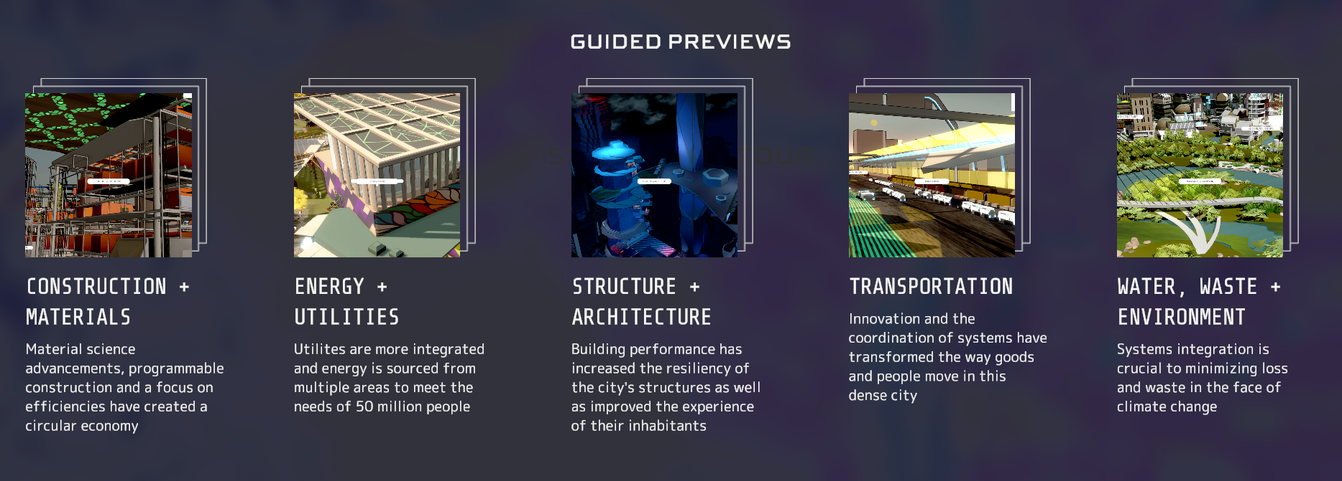

Figure 1. Two topic filters in Mega City 2077

* ***Phase II –*** ***Identification of new theory and technology for addressing the challenges, due March 14, 2024***
  + According to the descriptions and references of the case, decide the scientific challenges of the selected case.
  + Find the emerging technologies that have the potentials to address the challenges or improve the project performance in this case (e.g., BIM, computer vision, natural language processing, automatic translation, blockchain, data mining, data analytics, big data, human behavior tracking, and analysis techniques)
  + Identify the risks of technical use
  + **Delivery**: **2,000 words** proposal (can include the 800 words from Phase I)
  + Based on Phase I’s 800 words, add more details about the case and underlying challenges, and conduct a search and analysis of the technologies and methods that could help improve that performance dimension of your case project. Summarize evidence and data from literature or data sources to support your claims about how the technologies and new methods could address the problem of the case project studied by the team.
  + Project Mid-Semester Presentation and Progress Report Due (March 14, 2024)
* ***Phase III – Implementation solutions in a real city***
  + Demonstrate your intervention in the existing building, according to the case proposed in the real city selected by the team
    - Please clearly identify one or two challenges of Mega City, and how you imagine your building can handle those challenges in future mega cities. Choose any city as the location for your building.
    - Please use Revit model of the building space that your team already created
    - Please demonstrate at least one case that this building space needs a collaboration between two stakeholders who need Navisworks to resolve conflicts between their models
  + Examine the identified theories, technologies, or methods for addressing the challenges proposed in Phase II, and finalize the findings
    - It should convey how your new sensors, software tools, algorithms, or other techniques will work together to empower your building space and make it meet the future needs of a Mega City
  + **Delivery**: **4,000 words** experiment reports (can include the 2000 words from Phase II)
    - Based on phase II’s 2,000 words, demonstrate an intervention in your building space, according to the case proposed in the real city selected by the team. Examine the identified new theories, technologies, and the content learned from the class for this new building to address the challenges proposed in Phase II and summarize the experiment processes and results. (Due April 25, 2024)
* ***Phase IV – Final Report and Presentation***
  + BIM and technology for future cities (please integrate what you have done in the previous phases into this section of the report)
    - Use case description (from your Phase I report)
    - BIM, technologies, and other tools that address the challenges identified in the use case (adapted from your Phase II report)
    - How the BIM and new technology implementation can make a real-world city better? (from your Phase III report)
  + Provide suggestions for the next version of the ASCE Future Vision platform
    - Add a dialog on Mega City 2070 platform, and suggest new resources to the platform
    - What are the most valuable and interesting things you have learned from Mega City 2070?
    - What additional things would you suggest – integrating certain data sets, research results, data and information visualizations, and specific data interpretations that could help you learn challenges in future cities
    - Any other thoughts about Mega City 2070?
  + Summarize a list of critical tasks for achieving:
    - What have you learned?
    - What do you find most useful - technology, science, or theory?
    - What do you think is significant could be added to the case?
  + **Delivery**: **4,500 words** term project report, and a 10-min presentation (10 -15 slides) for introducing the findings
  + Final Report and Slides (Due May 7, 2024) – Please integrate what you have created into a final report according to the instructions above. Please do not just send in your previously submitted files!
  + Final Presentations of Term Projects (Due April 25, 2024)
* **Cross-cutting issues that could help the team develop your team project**
  + Use of discussion board integrated with Mega City 2070 and resources available there as literature (please see figures below) - while searching additional literature or data and information sources

# Please follow the detailed instructions below to complete Phase I of the course project.

* Please work as **a team** (a team should have a minimum of 5 to a maximum of 6 students);
* **Delivery**: **800 words** introduction of the case, at least one figure for introducing the case **(please cite sources and give credits to sources of information, please DO NOT directly copy and paste otherwise you will get a ZERO**), please select a project that has some interesting socioeconomic impacts or other types of impacts so that you can tell that this is an interesting and important case. The descriptions and referenced research could be found in the left panel of Mega City 2070 User Interface, as shown in Figure 2.

**Your short note should address the following questions:**

* What project will form the case study of your term project – please see a list of example projects on the next page. You could also search for your project as long as you are confident that you can find sufficient information for the project and how certain technologies could help this particular case.
* Each team member should take a role in this case analysis, so your document should explain how teammates’ work will rely on each other and ensure that all team members learn about the whole idea developed by the team.
  + Each team member should have at least one edit history on a Box Note for collecting ideas and writings from team members and gradually making a document toward case selection note (Phase I), identification of new theory, and technology for addressing the challenges (Phase II), implementation solutions in a real city (phase III) and project final report and presentation (Phase IV)
* Why is this project important or interesting? What are the social, technical, economic, or other interesting impacts of this project?
* What are the factors that are influencing the performance of the project? Please specify the performance metrics that are affected by specific factors. Environmental factors? Workforce? Regulation? Contracts? International collaboration? Resource availability? Supply chain reliability? Union? Safety regulations and inspections? Other factors?
* What have you found about possible technologies or other methods (novel contracts or delivery methods, new construction methods, new regulation or policy, new site management organizational structures) that could help improve this case's performance? Please specify specific performance metrics and how these technologies or methods could potentially influence the project performance, and how various factors could play roles in using new technologies or methods.

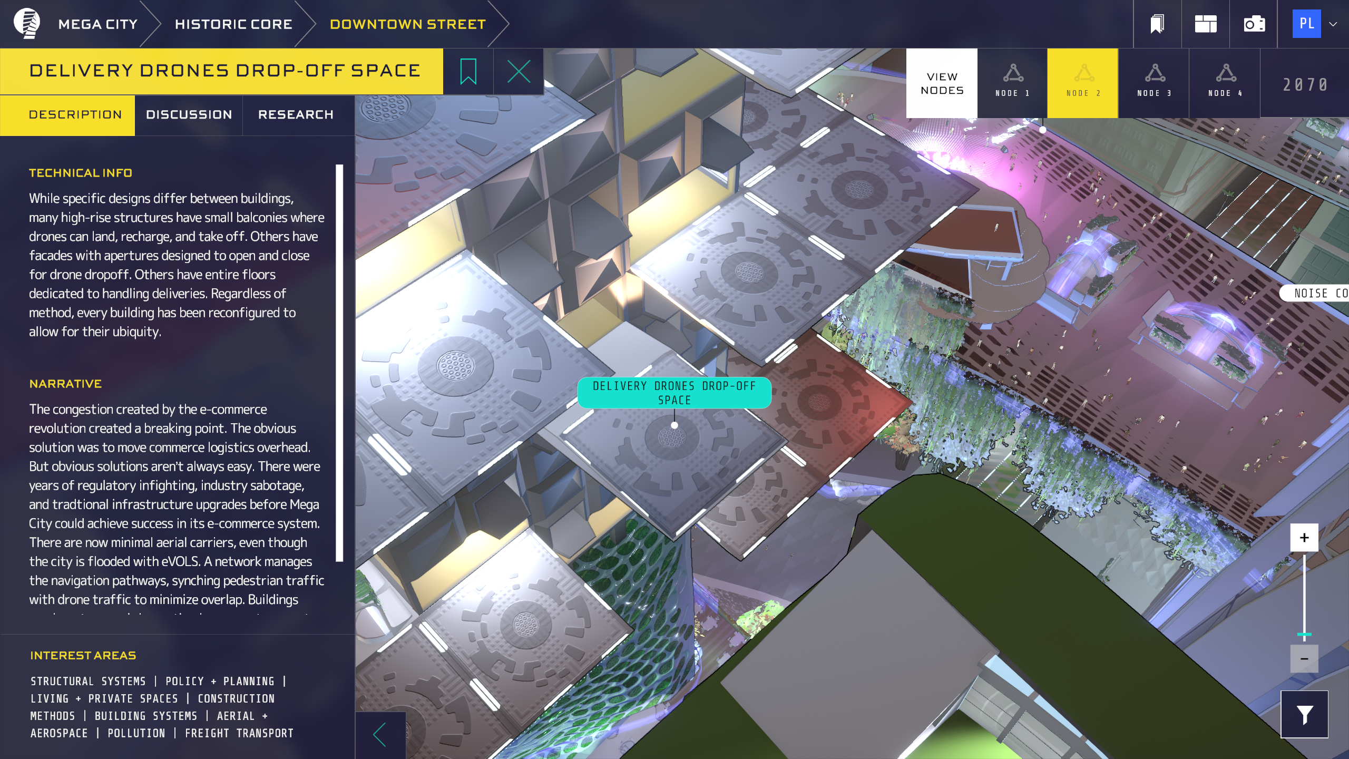

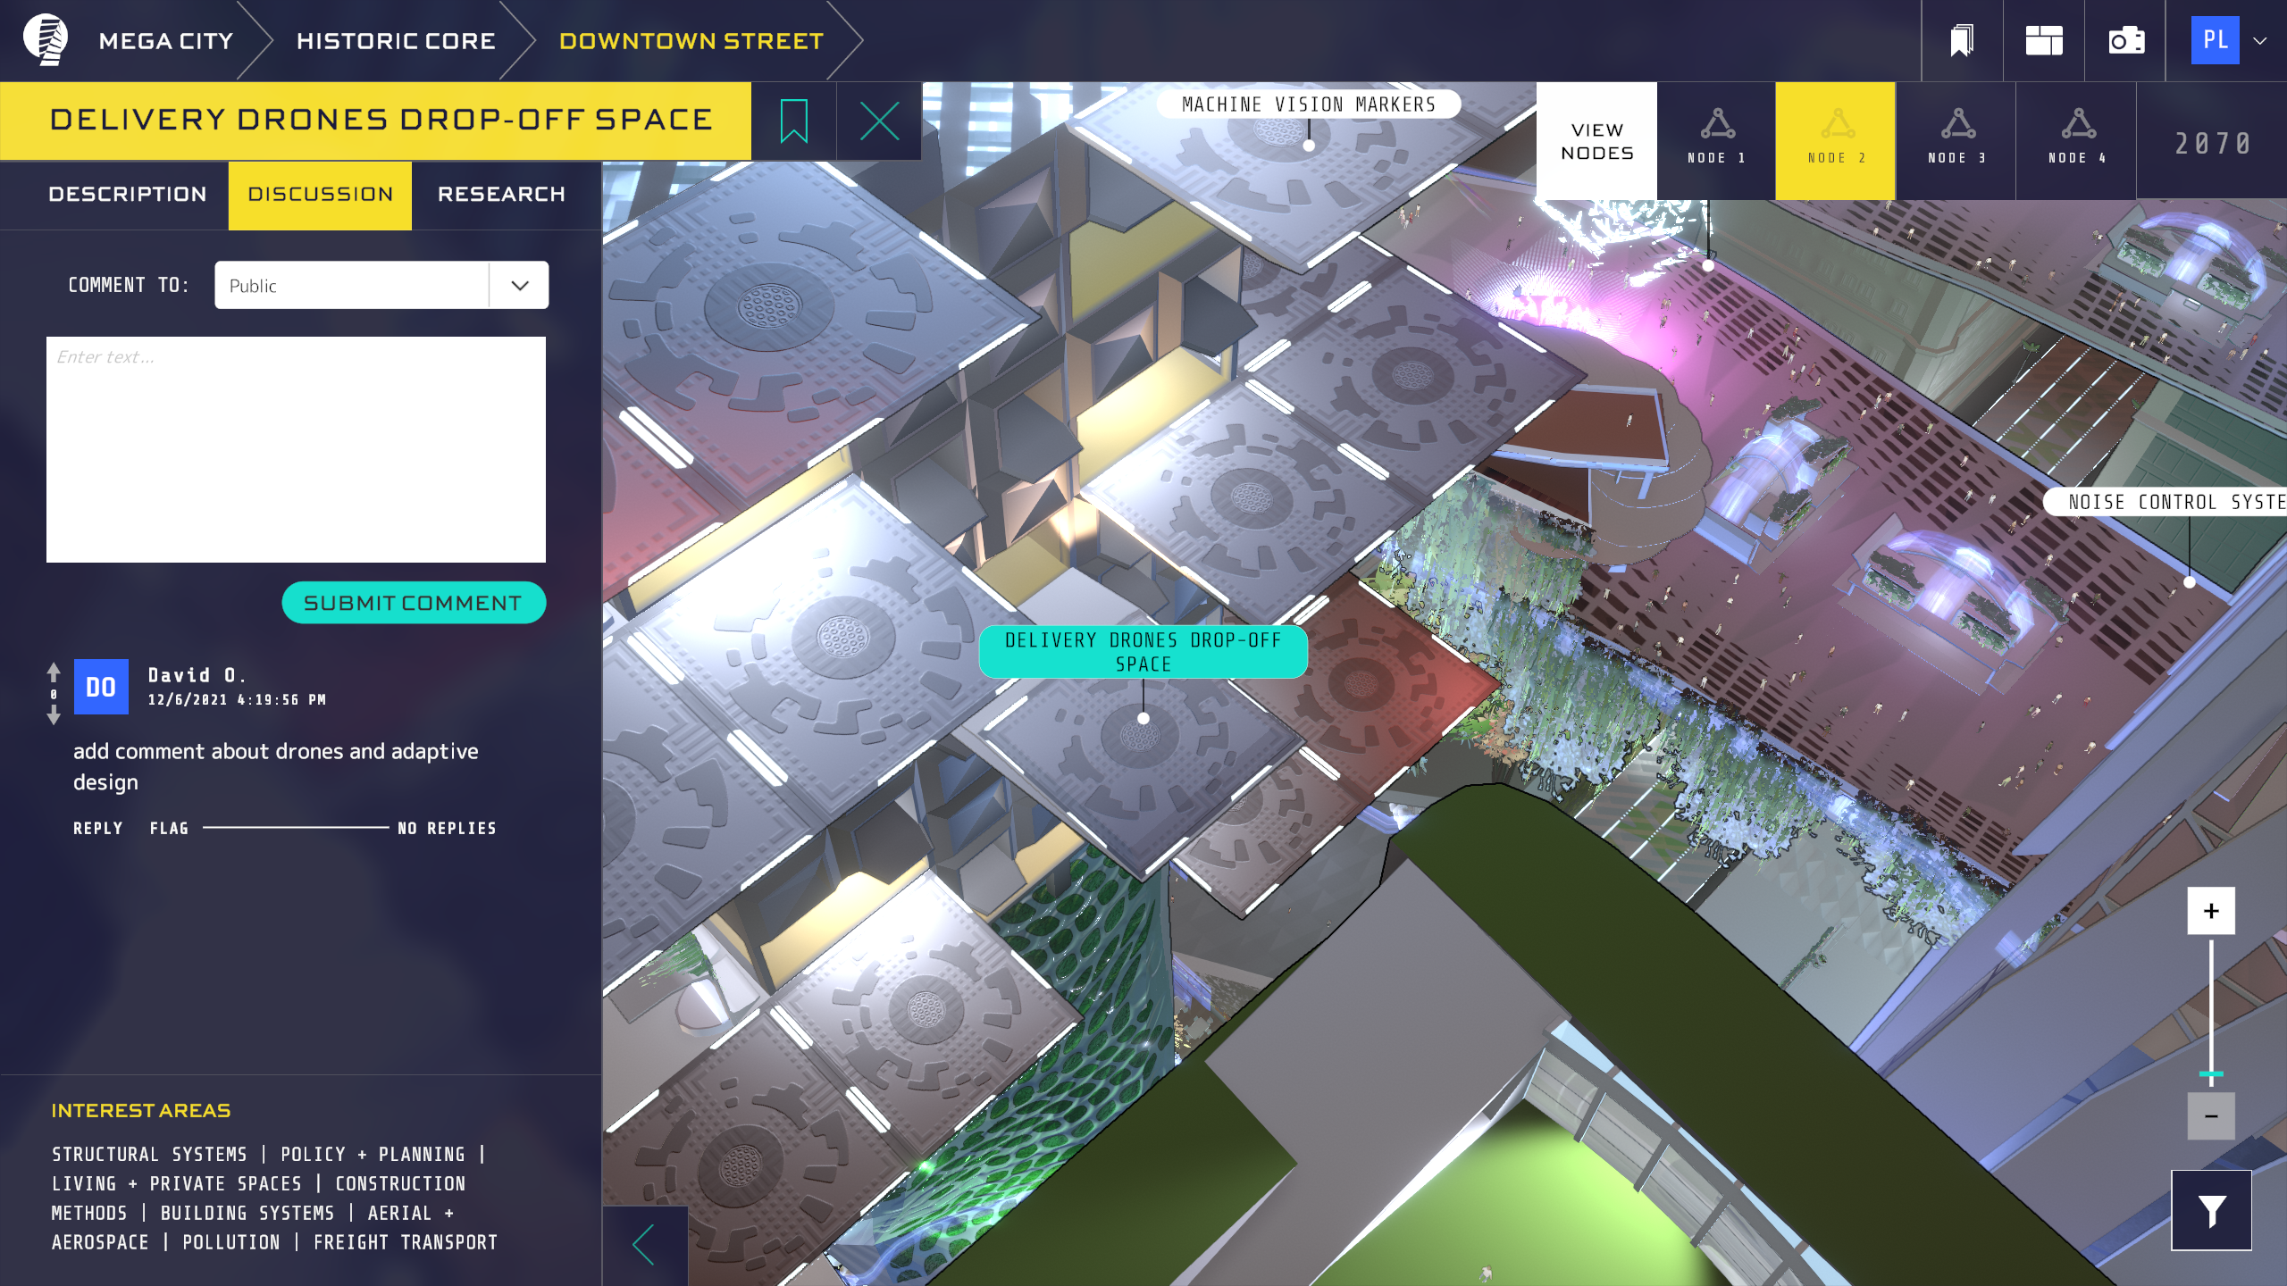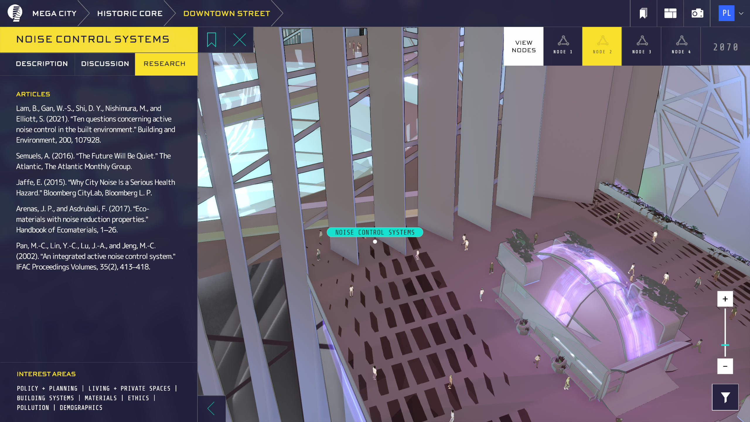

Figure 2. The descriptions, discussion, and referenced research of selected projects

***----------***

***Structural & Architecture:*** *Architecture intro temp; Mixed-use high-rise; Reconfigurable event space; Multi-purpose rooftop; Green infrastructure; Preserving historic facades; building on top of historic structures; preservation exoskeleton; Soil stabilization; Arena infrastructure; Modular housing.*

***Construction & Materials:*** *Programmable construction sites; Buildings that build themselves; AI and trust; Liminal structures + second lives; Floor adaptive architecture; Floating wetlands; Home recycling 3D printers; Scalable modularity; Temporary housing; Personal producing power; Community fabrication.*

----------

# Please follow the detailed instructions below to complete Phase II of the course project.

* Please work as **a team** (a team should have a minimum of 5 to a maximum of 6 students)
* **Delivery: at least 2,000 words** proposal (can include the 800 words from Phase I, extending the Phase I document into a more detailed document)
  + Focus on examining one or two project performance dimensions to study:
  + Based on Phase I’s 800 words, add more details about various factors that influence the performance dimension, and identify a few potential technologies or methods that could help improve that performance dimension of this case.
  + **At least one figure** for explaining an example that certain factors can influence the performance dimensions focused
  + **(please cite sources and give credits to sources of information, please DO NOT directly copy and paste otherwise you will get a ZERO**), please select a project with some interesting socioeconomic impacts or other types of impacts so that you can tell that this is an interesting and important case that needs good management.
* **Teamwork principle**
  + Each team member should take a role in this case analysis, so your document should explain how teammates’ work will rely on each other and make sure all team members learn about the whole idea developed by the team.
    - Each team member should have at least one edit history on a Box Note for collecting ideas and writings from team members and gradually making a document toward case selection note (Phase I), identification of new theory, and technology for addressing the challenges (Phase II), implementation solutions in a real city (phase III) and project final report and presentation (Phase IV).

**Your short note should add more details in your answers to the questions answered in the Phase I report (that 800 words document submitted for Phase I), as suggested in the yellow portions below:**

* Case study description:
  + (Your answer this in Phase I) What project will form the case study of your term project – please see a list of example projects on the next page, and you could also search for your own project as long as you are confident that you could find sufficient information for examining performance metrics of the project, and how certain technologies could help this particular case.
  + (Your answer this in Phase I) Why is this project important or interesting? What are the social, technical, economic, or other interesting impacts of this project?
  + (Please add more details by answering these questions) Please add at least one figure to show specific facts and data to support your arguments in your answers to the following questions:
    - Any specific data that you can use to illustrate the importance of the project to society? Which communities are benefiting from the project? In what forms? Any news or data reported quantifying the benefits brought by the project?
    - Any potential risks of this project to society? Any data or statistics could help you illustrate the project's potential risks or negative impacts on society?
* Project performance analysis
  + (Your answer this in Phase I) What are the critical performance metrics that can help you evaluate the strengths and weaknesses of this case project? Safety? Productivity? Cost? Or Quality? Any other metrics?
  + (Your answer this in Phase I) What are the factors that are influencing the performance of the project? Please specify the performance metrics that are affected by specific factors. Environmental factors? Workforce? Regulation? Contracts? International collaboration? Resource availability? Supply chain reliability? Union? Safety regulations and inspections? Other factors?
  + (Please add more details by answering these questions) Please add at least one figure to show specific facts and data to support your arguments in your answers to the following questions:
    - Any examples illustrating the impacts of certain factors on the performance metrics selected by you? Any stories in the case you choose or similar projects to demonstrate such effects? Any statistics in similar projects or at the national or local levels to show correlations between the selected project performance and the factor (a figure leading such relationships would be great)?
    - Do any examples illustrate trade-offs between multiple performance metrics considered in your case study (e.g., higher productivity brings higher accident rates)? Any data or examples in the selected case or similar projects found by you in the literature that shows such tradeoffs?
* Technical solutions
  + (Your answer this in Phase I) What have you found about possible technologies or other methods (novel contracts or delivery methods, new construction methods, new regulation or policy, new site management organizational structures) that could help improve this case's performance? Please specify specific performance metrics and how these technologies or methods could potentially influence the project performance, and how various factors could play roles in this process of using new technologies or methods.
  + (Please add more details by answering these questions) Please add at least one figure to show specific facts and data to support your arguments in your answers to the following questions:
    - Any data or facts to show how the new technology could outperform the current methods used in your case or similar projects (e.g., using total stations for collecting 3D points in everyday practice, while 3D imaging systems can achieve faster and more accurate 3D points collection)? Any facts found by you in the materials describing the selected case or a similar project could help you understand the current practice and the limitations of the methods used in the chosen case or similar projects? What specific technical specifications or technical testing results found in the literature or online materials could help you explain such advantages of the new technologies? Any figures to show a quantitative comparison of the latest technology against the current approach?
    - Any data or facts showing the technical barriers or challenges that impede people from effectively using the selected technology to improve the performance metrics of your project? Any data and facts or figures from research reports to show you such challenges? Please do not just list challenges; please search facts or stories, or statistics that could quantify the costs of using the selected new technology in your case.

# For Phase III, please use the cover page instructions – you already have a good proposal, learn some software tools. Now please release your creativity to implement the ideas of your case study in a real-world city!

# For Phase IV, please integrate all you have produced in the previous phases into a final report, a presentation (slides). The team must present the slides on April 25, 2024, and submit the final report by May 7, 2024.